Using Hardware Virtualization to Protect Commercial Software in Commodity Operating Systems

Abstract
Commodity operating systems are usually large and complex, and consequently, the software protection and the security it provided are often inadequate. As a result, commercial software and shareware use various ways to protect themselves from piracy and data loss. To address the limitation, we introduce a virtual machine based framework called HBSP. In this framework, the protected application can communicate with the hypervisor and do any protection-related job in it, while the OS doesn’t have any references to the hypervisor. This allows the operating system to carry out the task of running the application, without knowing anything about the hypervisor. Thus, this framework can be used to protect a software effectively.
HBSP takes the advantage of memory –hiding, a mechanism that hides any piece of memory by unmapping the guest virtual page number (GVPN) with the guest physical page number (GPPN). This mechanism offers an additional protection by restricting the access to a piece of memory, which can’t be discovered by scan address spaces.
We present the design and implementation of HBSP and give an example on how we can use such an approach to protect commercial software and share software from cracked by dynamic analysis. Our design has been fully implemented and used to protect applications running on an unmodified Windows XP system, the most popular commodity operating system, while imposing unnoticeable overhead for both I/O intensive workloads and CPU-intensive workloads when operating at 10 second intervals.

1. Introduction
Nowadays, commercial operating systems are deployed every corner in the home, office, and government, and it also needed to install various commercial software on them. Unfortunately, most of the operating systems can’t provide adequate security and software protection due to the design and hardware limitation. Consequently, though it will raise the total cost on software development, nearly all the commercial software needs to implement their own additional protection module. However, the risk of attacking the target software still exists for the following reason:
First, hardware architecture protection is limited. Hardware architecture defines that the code running in the privileged mode has full access to the resources, While the code in the user mode can only access a limit range. So once the malicious code or analyzing tools is running in the privileged mode, no more powerful mode can be used to stop it.
Second, there are always bugs and debugging functions in the commodity operating system. The kernel and the 3rd party device drivers of a commodity operating system contain millions of lines of code. And nearly all the commercial operating system provide functions to see other process’s address space and attach a thread to the other process for debug use. As a result, there is no way to stop someone who intended to crack a commercial software.
Finally, current platform can’t verify the sender of a message. When verify a serial key of software via Internet connections, the kernel can’t tell about one message comes from the remote machine or a malicious program. Even the remote machine can’t distinguish if a verification request comes from the application or not.
To improve the situation, previous efforts have explored
Unlike other approaches, when using HBSP constructed hypervisor to protect applications, there is no need to change the existing operating systems or to add additional hardware from them, there is even no change to the control flow between the application and the OS kernel. HBSP makes use of hardware virtualization technology to add another layer between privileged mode and hardware. By using hypervisor, applications and existing host OS can be put into the virtual machine on the fly and continue running without noticing anything and vice versa when unloading the hypervisor. To achieve this goal, on one hand the hypervisor using memory-hiding approach to hide itself in the private memory region, On the other hand, it protects the software by handling hypercall. Consequently, the hypervisor runs transparently under the commercial operating system and holding important information about the application.
The following section presents the design goals of HBSP framework. In section 3, we will explain the framework implementation and the challenges when introducing in memory-hiding. Section 4 describes an example to protect a software by verifying itself with the help of HBSP framework in detail, as well as how it can prevent cracking by dynamic analysis. Section 5 shows how we apply our implementation to a default installation of the Windows XP and evaluates the overall performance. Section 6 reviews related work. Future work is discussed in section 7. Finally we will conclude the ideas in section 8.

2. Design Goals
Hardware Enabled Virtualization (HEV) Technology can be adopted as a way of software defense. Consequently, we built this HBSP framework offering another line of software protection even on an untrusted environment. We will talk about its features first, and then the limitations we have not studied yet.

2.1 Features
HBSP framework is tailored from BluePill Project, We remove the anti anti-VMM detection and migrate it onto the x86 platform. As a result, we build a framework to protect software with the following advantages:

Install/Uninstall on the fly. Previous approach on protecting software divides the space into safe zone and unsafe zone. Thus it requires modifying the OS and even the boot sequence. Some other approaches also require the change on how software is packaged and used. By install/uninstalling hypervisor on the fly, It doesn’t affect any bit of the legacy OS, as well as the user experience.

Flexible Configuration. In order to support various ways to protect software, for example, to use Hardware-Virtual-Machine (HVM) protecting the application data and OS kernel, HBSP framework supply a rich set of low level interfaces to configure VMCS (Virtual Machine Control Structure) structure and memory strategy. While in the high level it also offers interfaces to initialize/start/shutdown the hypervisor. However, it’s not advised to keep all sensitive data or code in hypervisor for performance reasons.

Support for Other HEV technology. Currently HBSP framework supports Intel VT technology. Despite of this, there is also AMD SVM technology which is also largely adopted in the market. To minimize the cost when refactoring the hypervisor to support both platforms, we build a layer to hide the hardware difference. Thus, extending hypervisor platform support doesn’t affect other parts, as well as the protected software.

2.2 Limitations
As a hypervisor framework, HBSP can be used to implement software protection logic, but provide no availability in the face of anti-VMM detector by default. Thus a hypervisor is possible to be detected in a hostile environment, for example, it requires nearly a hundred of times of cycles to handle an instruction trap in hypervisor than executing the instruction in guest machine. Also, the TLB cache is polluted when running the trap handler routines. And a malicious kernel can still record an application’s memory access patterns, thus the hypervisor can be tracked.
Second, though HBSP framework can be configured to use memory-hiding technology to hide itself under guest OS, its security is ultimately decided by the 3rd party hypervisor implementation and the software it going to protect. Bugs or security weakness could allow a malicious kernel or software steal any sensitive data from application. Despite of this, memory-hiding technology doesn’t protect against a DumpPhysicalMemory command.
Third, we make no attempt to let the memory-hiding technology support PAE mode, though it’s a desirable function and not so hard to implement. We have not tried to support this in the current system.
Finally, HBSP framework is designed to support only 1 guest machine at the moment, though a typical hypervisor can support more virtual machines as a nature. Regardless, HBSP framework offers a new approach in security, it brings in a valuable layer of protection, and requires no change to the hardware and the operating system.

3. Framework Implementation
Realizing the HBSP Framework design goal running on unmodified commodity operating systems has proved challenging. In this section we firstly introduce the control flow of HBSP Framework and how it controls the guest OS, then describe the HBSP framework architecture and the execution flow. Later we explain how it adopts the memory-hiding technology. In addition, we talk about the anti-debugging mechanism to enhance memory-hiding.

3.1 HBSP Framework Control Flow
Since HBSP Framework is built on HEV technology, its behavior is much like a guest machine controller on top of the physical hardware. Consider a single guest machine running on the top layer. At any point of time, the whole system can be only in 1 context from the following three: guest application (Ring 3), guest kernel (Ring 0/1) and hypervisor (VMM). Both hypervisor interested events and ones should not be handled in the guest machine will transfer control to hypervisor. And hypervisor transfer control back to the guest machine explicitly after it finish handling the events.
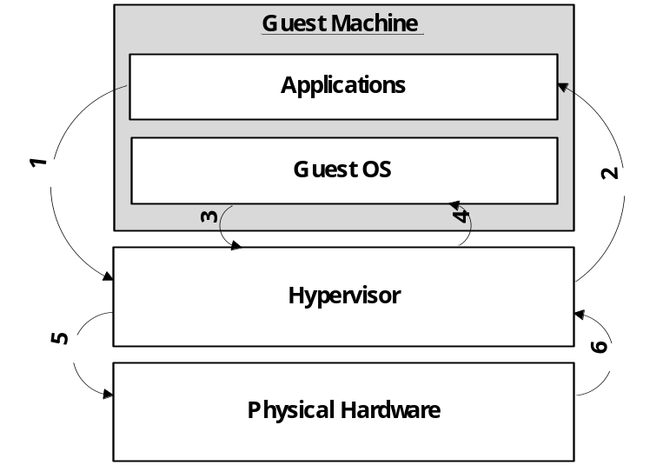
Figure 1. Basic State Transition Diagram
Figure 1 presents the basic state transition diagram. Both guest user mode instructions and guest kernel mode instructions could cause a #VMEXIT event to trap into the hypervisor. When guest applications execute a CPUID instruction, a hardware #VMEXIT event is generated and hardware informs hypervisor to start handling the event (Transition 1). The hypervisor examines the #VMEXIT reasons as well as the guest machine state which is stored automatically to determine how to handle it properly, hardware further uses them to resume the guest machine’s execution and transfer the control back to the guest machine (Transition 2).
Guest kernel has more chance to trap into the hypervisor, for example, a guest machine always causes #VMEXIT event at the moment reading MSR registers when the hypervisor configured monitoring RDMSR instructions with the help of HBSP Framework. Then the hypervisor does the same handling process as that with application (Transition 3, 4).
Some traps caused by requiring guest machine interact with physical hardware, for example, I/O related instructions. In HBSP Framework, a hypervisor also can be configured to intercept such operations. A Hypervisor mediates between guest machine and physical hardware in such condition, performing any additional operations on the results (Transition 5, 6), then returning control to the guest kernel or guest applications. With this approach, a hypervisor can cheat a malicious kernel and software to protect applications.

3.2 HBSP Framework Architecture
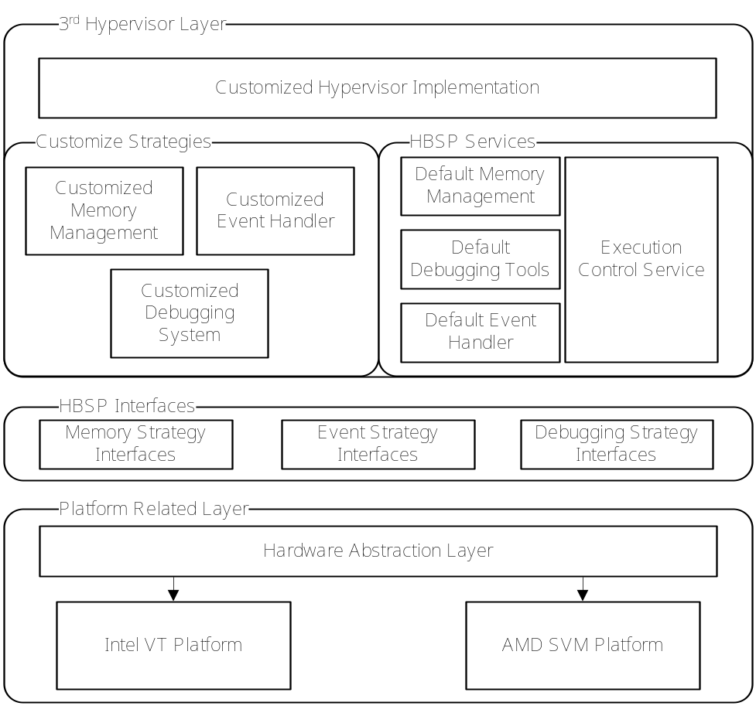

Figure 2. HBSP Framework Architecture. HBSP Framework consists of 3 Layers. User defined hypervisor will be constructed on the top layer, with the help of the HBSP Services and the HBSP Interfaces.

HBSP Framework uses a layered structure, providing a low level abstraction of the HEV technology as well as a selected set of interfaces. HBSP leverages this mechanism to enable a hypervisor developer implementing customized strategy and logic to protect software.
Figure 2 provides the HBSP Framework architecture. It is divided into 3 layers: Platform Related Layer, HBSP Interfaces and 3rd Hypervisor Layer. In this section we describe all the layers and the challenges to implement it in detail. The way to make use of this framework will be explained in Section 4.

Platform Related Layer. All the platform related implementations are held in this layer. Intel VT and AMD SVM are the most common implementations of HEV technology on x86/x64 platform, but as there are differences between Intel VT and AMD SVM, e.g. the differences in HEV-related instructions, in checking platform and in virtual-machine control structures, it requires a Platform Related Layer being responsible for hide the differences and provide an abstraction of HEV-support to the upper layers.
In Hardware Abstraction Layer, HBSP Framework requires any implementation of HEV technology to support the following routines (as we mentioned earlier, HBSP Framework is tailored from BluePill Project, so we keep most of the procedure names):
ArchIsHvmImplemented() This procedure checks if a hardware platform supports HEV technology.
ArchInitialize() This procedure takes the response of initialize the hypervisor and guest machine, it can also enter the VMM mode if needed.
ArchVirtualize() This routine is responsible for starting the guest machine. As a result, the original OS is put into the virtual machine and continue executing instructions with no sense.
ArchDispatchEvent() This function dispatches events to the proper handler. It is invoked under the following condition: the hypervisor is using the Default Event Handler supplied in HBSP, and a #VMEXIT event is occurred in virtual machine.

HBSP Interfaces. To allowing hypervisor developer to insert their own resource and hypervisor management called strategy into the Platform Related Layer, HBSP framework exports a set of interfaces to fulfill the request. Take Memory Strategy Interfaces as an example, to demand memory for the future use, the Platform Related Layer calls proper functions declared in this set of interfaces. If Memory Hiding Strategy is used as the definition of the current memory strategy, HBSP framework always uses its private page table to allocate memory for the caller. While adopting The Default Memory Strategy as the current memory strategy leads to delegating all the memory management jobs to the Windows system.

3rd Hypervisor Layer. This layer is concentrated on implementing customize hypervisor logic. Building on top of HBSP Interfaces, HBSP framework also supply services and default HBSP Interfaces implementation to accelerate constructing a hypervisor. As in the case of replacing these services with customized strategies, only changing hypervisor configurations and implementing necessary HBSP interfaces are required. By default, the build-in HBSP Services mainly include:
Default Memory Management. HBSP Framework supports two memory management strategies by default. The Default Memory Strategy service uses the Windows kernel API to manage the hypervisor’s code and data memory. Thus, any allocation and deallocation to this address space can be detected by other processes. In the contrast, the Memory Hiding Strategy uses memory-hiding technology. The contents of the whole hypervisor’s address space are hidden from the OS’s view; see Section 3.2 for details.
Default Event Handler. Default Event Handler is used to register a callback function with the indicated #VMEXIT event. When an #VMEXIT event happens, hardware automatically record the #VMEXIT reason in the VMCS before executing the first instruction in hypervisor. For the performance optimization, each #VMEXIT Reason is linked to an independent event handler chain in HBSP Framework. It cuts down the total time spending in the hypervisor with the help of limiting the length of the chain.

3.3 Memory-Hiding Technology
We realized that if we don’t make Hypervisor to be untouchable from Guest OS, the Hypervisor will be deconstructed easily. So in this section, we explain how to hide the Hypervisor from the Guest OS. All of the memory for the Hypervisor will not be detected by Guest OS after the Hypervisor is on and no application even the Guest OS is able to deconstruct it.

3.3.1 Limitation without Memory-Hiding
In fact, we all know that the CPU translates virtual addresses into physical addresses. And this procedure which is done by hardware could not be influenced by the Guest OS. But the relationships between certain virtual address and certain physical address are stored in the Page Tables which means the Guest OS know the relationships too.
Before the memory-hidden mechanism was implemented, the Hypervisor’s initialization procedure runs as an application in the Guest OS and the memory requests and allocations for Hypervisor are done by Guest OS. So, the Hypervisor was visible to Guest OS what means the Hypervisor can be easily modified and deconstructed by Guest OS. Figure 3 shows the address translation for this situation.
In this situation, although the system has two models: root model and non-root model. But in non-root model which means in Guest OS, the mapping relationships between Hypervisor’s virtual address and physical address are stored in the OS’s Page Table. So, the Hypervisor’s memory could be visited and its contents can be modified in some ways. And this is intolerable to the security, stability and reliability of Hypervisor.
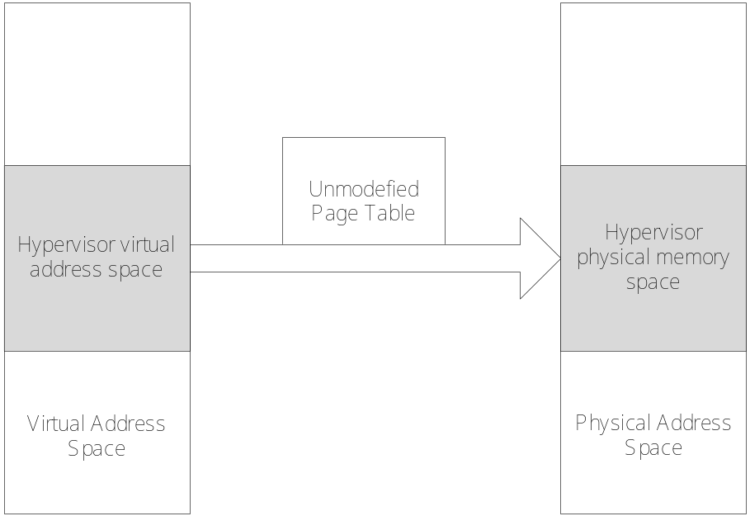
Figure 3. Translation without Memory-Hiding

3.3.2 Memory-Hiding Strategy Implementation
We cannot change the address translation mechanism, so, we take a moderate way. While the Hypervisor is initializing, it will copy the Guest OS’s Page Table，especially the kernel space’s because the memories for Hypervisor are allocated in the kernel space. And this Page Table will be saved in the Hypervisor and will not be modified.
Then, we modify the Guest OS’s kernel space Page Table, change the mapping-remap the hypervisor’s virtual address to a spare physical address. We modify the PTE of Hypervisor’s virtual address by using a spare page’s. Then, while the translation for the hypervisor’s virtual address happens, it will be translated to a spare page’s physical address. All of the modifying actions are done after Hypervisor was on, before Hypervisor launched. While the Hypervisor is on, the system enters the root model, and all the operations would not be detected by Guest OS. So, those physical memories are still signed allocated and will never be freed.
As figure 4 shows, the Hypervisor uses the really Page Table it copied as well as the Guest OS uses modified Page Table. By the modified Page Table, in Non-root model, the translation procedures will be done by using modified Page Table, the physical memories of the Hypervisor’s are out of Guest OS’s control and also cannot be accessed. But while VMEXIT happens, the system enters Root model, the Hypervisor will use Really Page Table, and so could find itself exactly and runs successful.
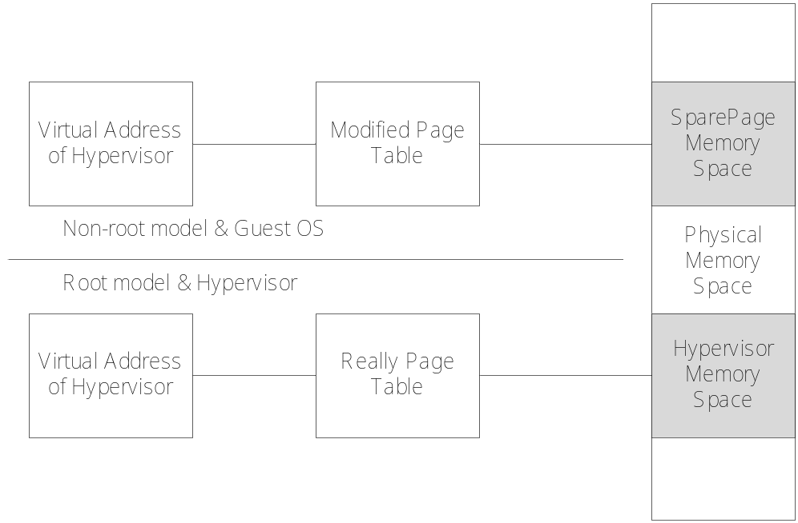
Figure 4. Translation with Memory-Hiding

4. Protecting Software with HBSP
To prove it is practical and efficient to adopt HBSP Framework protecting software, we develop a simple hypervisor called SNProtector to protect an application from cracking by dynamic analysis its serial key validation algorithm and registration state. The target application protection goal is: Even the validation of the application side is publicly known, the application still remains protected as long as the SNProtector hypervisor is running.
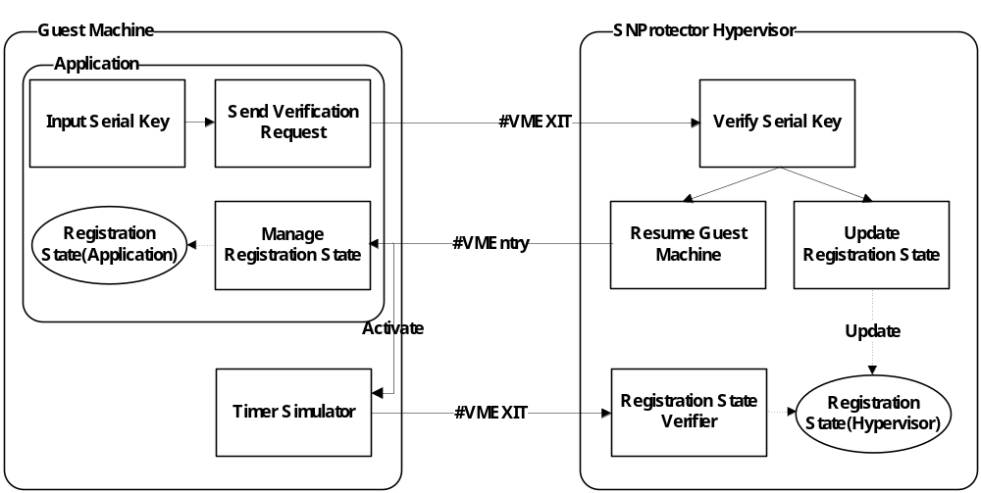
Figure 5. SNProtector Design and Usage Model
Figure 5 shows the design and the usage model of SNProtector. To fulfill the protection goal, it is important to use memory-hiding strategy to hide its code and data segment and present no view to the guest OS, as well as making use of hypercalls causing #VMEXIT event to ensure that the guest machine state is stored before continuing executing any instruction in guest machine or hypervisor. Thus it is hard for an attacker to find out and lock the registration state in the memory for the hidden pages are never referenced in the virtual space.
It’s also important to realize that the classical way of protecting software using serial key is vulnerable because it only verifies the serial key for only once. To solve this problem, SNProtector sets up a timer simulator, it triggers to verify the registration state in the hypervisor side after a fixed amount of CR3 switches. As a result, it is impossible for an attacker to find out which instruction exactly causes the timer trap into the SNProtector hypervisor and intercept it on a multi-task operating system like Windows.
Consider of reducing the impact on the application performance, SNProtector also stores the registration state in the application side. This reduces the number of traps since the application doesn’t need to query the registration state initiatively. Although it costs tens of hundreds of cycles to handle a VMM trap, the performance overhead when applying the protection is limited, see chapter 5 for detail.

5. Experiments and Results
All experiments were conducted on a desktop computer with a 1.83GHz Intel Core2 Duo processor and 2GB RAM. SNProtector is installed on both of the processors. Windows XP SP3 is selected as the guest operating system of the testbed.
I/O密集型的程序 1s，2s…10s的interval
CPU密集型的程序 1s，2s…10s的interval
或者 SPEC06/08的测试
Super pi, bzip2 , h264ref,sjeng11.2
Httpd,3dmark,TPC-app,TPC-E

6. Related Work
Hardware Enabled Virtualization Technology enables transparent intercepting guest OS exceptions and interrupts. This has been leveraged in the New Blue Pill project to intercept external timer source like HPET and Real Time Clock. Also, it enables another step of translate guest physical address into the machine physical address. Systems which employ this ability can be used for transparent page sharing , and transparent VM migration among physical machines.
Many previous systems have attempted to provide a higher-assurance execution environment by means of adopting Hardware Enabled Virtualization Technology. Proxos builds separate VMs, one of which is used to run the untrusted operating system, while the other VMs are running trusted ones. Protected applications are placed in the trust VMs, with the ability of using the resource in the untrusted VM. Another example is Overshadow, with the help of the additional layer of address translation, it provides different views of the sensitive application’s address space according to the current context. Without affecting the existing OS and legacy protected application, even the hardware, kernel and other programs can only get the encrypted content from the protected application’s virtual space.
Other hardware-based software security approach including the Intel’s Trusted Execution Technology, provides isolated protected execution environment, which gives no right to a unauthorized software even to observe. What is more, it also provides protected input and storage channel to ensure the data security. However, this approach can only be enabled on special hardware.

7. Future Work
未来工作包括：先于操作系统启动，拦截中断，VMX Interception Timer,与TxT结合实现Hypervisor的自我完整性检验。

8. Conclusion
In this paper, we have presented the architecture and design of HBSP Framework, which can be used to implement hypervisor running under the guest OS and intercepting indicated guest machine actions without modifying existing OS and hardware, even software. Especially, the hypervisor constructed by HBSP Framework can be install/uninstall on the fly and hide its space from the OS view with the help of memory-hiding strategy.
This capability is enabled by patching the page table of guest OS while holding a real one in the hypervisor. This causes some anti-debug tools and hypervisor detect tools invalid in the face of HBSP Framework. Thus it constructs a safer execution environment for a hypervisor layer application or software protector to store sensitive data and codes.
At last we build a simple serial key protector using HBSP Framework. A series of experiments on Windows system has prove that our approach brings in little overhead to the existed environment. We believe it is a practical approach to protect software in commodity operating systems.

实验部分：
比较几个软件（最好是像类似于Apach HTTP Server，并且有源代码可编译并且要在Windows下运行的，或者像SPEC系列？）在未加入保护和加入保护下

Invisible Things Lab. BluePill Project. http://www.bluepillproject.org/stuff/nbp-0.32-public.zip, March 2008.
R. Ta-Min, L. Litty, and D. Lie. Splitting Interfaces: Making Trust Between Applications and Operating Systems Configurable. In Proceedings of the Seventh Symposium on Operating Systems Design and Implementation, pages 279–292, November 2006.
T. Garfinkel, B. Pfaff, J. Chow, M. Rosenblum, and D. Boneh. Terra: A Virtual Machine-Based Platform for Trusted Computing. In Proceedings of the Nineteenth ACM Symposium on Operating Systems Principles, pages 193–206, October 2003.
Xiaoxin Chen, Tal Garfinkel, E. Christopher Lewis, Pratap Subrahmanyam, Carl A. Waldspurger, Dan Boneh, Jeffrey Dwoskin and Dan R.K. Ports: Overshadow: A Virtualization-Based Approach to Retrofitting Protection in Commodity Operating Systems. In ASPLOS’08, March 2008
Nick L. Petroni, Jr. and Michael Hicks: Automated Detection of Persistent Kernel Control-Flow Attacks. In CCS’07, October 2007
Invisible Things Lab: Is GameOver() Anyone?. In Black Hat USA 2007, May 2007
Invisible Things Lab: Is GameOver() Anyone?. In Black Hat USA 2007, May 2007
E. Bugnion, S. Devine, and M. Rosenblum. Disco: Running Commodity Operating Systems on Scalable Multiprocessors. In Proceedings of the Sixteenth ACM Symposium on Operating Systems Principles, pages 143–156, October 1997.
C. A.Waldspurger. Memory Resource Management in VMware ESX Server. In Proceedings of the Fifth Symposium on Operating Systems Design and Implementation, pages 181–194, December 2002.
M. Nelson, B.-H. Lim, and G. Hutchins. Fast Transparent Migration for Virtual Machines. In Proceedings of the USENIX Annual Technical Conference, pages 391–394, April 2005.
R. Ta-Min, L. Litty, and D. Lie. Splitting Interfaces: Making Trust Between Applications and Operating Systems Configurable. In Proceedings of the Seventh Symposium on Operating Systems Design and Implementation, pages 279–292, November 2006.
Xiaoxin Chen, Tal Garfinkel, E. Christopher Lewis, Pratap Subrahmanyam, Carl A. Waldspurger, Dan Boneh, Jeffrey Dwoskin and Dan R.K. Ports: Overshadow: A Virtualization-Based Approach to Retrofitting Protection in Commodity Operating Systems. In ASPLOS’08, March 2008
Intel. Intel Trusted Execution Technology Architecture Overview, September 2006.

